Writing Physics Papers
(Phys 151W - Intermediate Laboratory)

Igor Strakovsky, Physics Department, CCAS, GW

[Publish or Perish - Presentation of Scientific Results]

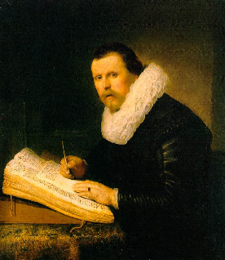

Phys151W (Intermediate Laboratory) is focused on significantly improving the students' writing skills with respect to producing scientific papers, to do peer reviews, and presentations at the Physics Department Mini-Workshop.

OUTLINE

· Why are we writing papers?
· What physics journals are there?
· Structure of a physics article
· Style of Technical papers
· Hints for effective writing
· Submit & Fight

Why are We Writing Papers?

· To communicate our original, interesting, and useful research.
· To let others know what we are working on (and that we are working at all.)
· To organize our thoughts.
· To formulate our research in a comprehensible way.
· To secure further funding.
· To further our careers.
· To make our publication lists look more impressive.
· To make our Citation Index very impressive.
· To have fun?
· Because we believe someone is going to read it!!!

What Physics Journals are there?

Hard Science Journals
Physical Review Series:

· Physical Review A · Physical Review E
http://pra.aps.org/ http://pre.aps.org/
Atomic, Molecular, and Optical physics. Stat, Non-Linear, & Soft Material Phys.
· Physical Review B · Physical Review Letters
http://prb.aps.org/ http://prl.aps.org/
Condensed matter and Materials physics. Moving physics forward.
· Physical Review C · Review of Modern Physics
http://prc.aps.org/ http://rmp.aps.org/
Nuclear physics. Reviews in all areas.
· Physical Review D
http://prd.aps.org/
Particles, Fields, Gravitation, and Cosmology.

[Physical Review commenced publication in July 1893. It was organized by Cornell University professor E. Nichols and helped by the new President of Cornell, J. G. Schurman. The journal was managed and edited at Cornell in upstate New York from 1893 to 1913 by Nichols, E. Merritt, and F. Bedell.]

Applied Physics Series

· Journal of Applied Physics · Applied Physics Letters
http://jap.aip.org http://apl.aip.org

Hard Science Journals

European Physics Journal Series:

· EPJ A · EPJ E
http://epja.edpsciences.org/ http://epje.edpsciences.org/
Hadrons and Nuclei. Soft Matter.
· EPJ B · Europhysics Letters
http://epjb.edpsciences.org/ http://epljornal.edpsciences.org/
Condensed matter & Complex systems. Frontiers of physics.
· EPJ C
http://epjc.edpsciences.org/
Particles and Fields.
· EPJ D · Physics Letters B [Elsevier]
http://epjd.edpsciences.org/ http://www.elsevier.com/wps
Atomic, Molecular, Optical, & Plasma physics. Nuclear physics and Particle physics.

[From the time of its creation in 1845, the Physical Society of Berlin (Physikalische Gesellschaft zu Berlin) published Fortschritte der Physik and Verhandlungen, but by 1919, the Verhandlungen had become too voluminous, so a committee consisting of A.Einstein, E. Goldstein, Fr. Haber, E. Jahnke, K. Scheel and W. Westphal was formed.]

Nature & Science

· Nature: · Science:
http://www.nature.com http://www.sciencemag.org
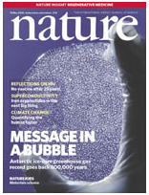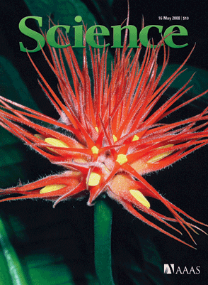

Soft Science Journals

· Physics Today:
http://www.physicstoday.org/
Official journal of APS, good review articles and research news.
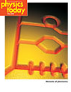
· Physics World: · Scientific American:
http://physicsworld.com/cws/home http://www.sciam.com/
IOP, good review articles. Popular science articles.

· American Journal of Physics:
http://scitation.aip.org/ajp/
Pedagogical physics research articles.

Impact Factor

How much is your Article worth?

· Institute of Science Information (ISI)
http://www.isiwebofknowledge.com/

ISI Impact Factors of selected Physics Journals - 2002

[Natural Sciences: There are 6,125 active journals including 145 high cited book series.]

Average citation per article:
Nature 30.432
Science 28.956
Rev Mod Phys 23.672
Adv Phys 13.952
Phys Rep 12.645
Phys Rev Lett 7.523
Nucl Phys B 5.409
Phys Today 5.000
Phys Rev D 4.358
Appl Phys Lett 4.207
Phys Rev B 3.327
Phys Rev A 2.986
Phys Rev C 2.848
Phys Rev E 2.397
J Appl Phys 2.281
EPJ E 2.188
EPJ B 1.741

Journal Citation Report - 2005

Journal Summary List: Nuclear Science & Technology; Nucl Phys; Particle & Fields.

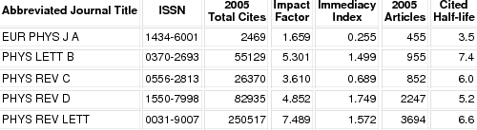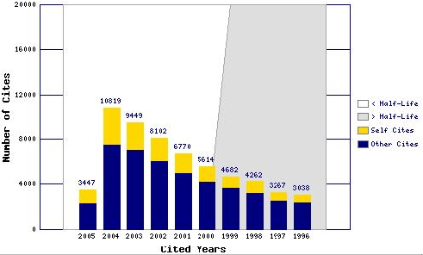

Citations

How much is your article really worth?

http://www.isiwebofknowledge.com/

http://www.slac.stanford.edu/spires/

SPIRES HEP Reference Search

According to the SPIRES-HEP database, the HEP preprint database has over 600,000 high-energy physics related records since 1974 and just under 20,000 of these have more than 50 citations (4 %).

Preprint Archive

Free, Fast, Referee free, Money free

arXiv has become the most widely used preprint server among academics in the physical sciences.

http://arxiv.org/
Open access to 607,993 e-prints in Physics, Mathematics, Computer Science, Quantitative Biology, Quantitative Finance and Statistics

[It received more than 60,000 new submissions in 2009, has about 400,000 registered users and provides 2.5 million articles download per month.]

Structure of a Physics Article

Short Letters (PRL, APL, Rapid Communications …)
[1 – 4 pages]

· Title.
· Abstract.
· Homogeneous body includes introduction and acknowledgments.
· References.
· 0-4 figures/tables.
· At most paragraph titles.

Regular Articles
[4 – 500 pages]

· Title.
· Abstract.
· Introduction.
· Body sections.
· Conclusions/Summary.
· Acknowledgments.
· References.
· Appendices.

Title

Informative, Catchy, and Concise.

Semicolons?
Why not, if it helps, though some consider them bad taste.

Abstract

Concise, Direct, Informative.

Passive or Active voice?
I prefer active, though in longer abstracts an occasional active assertion may be enlivening.
``We have measured ...” or ``We have calculated ...”

· Abstracts are now more important than ever due to the large and increasing number of articles. One cannot read all the papers in each issue of PRL, not even in ones own field. Abstracts should state major findings, even some specifics (numbers, formulas showing basic trends.)

· Abstract has to have a punch-line.
After reading the abstract professionals not acquainted with your work should understand what your experiment goal was and the concept/principle you used to achieve this goal.

· What you should not do is use both in the same abstract.

Example of Abstract

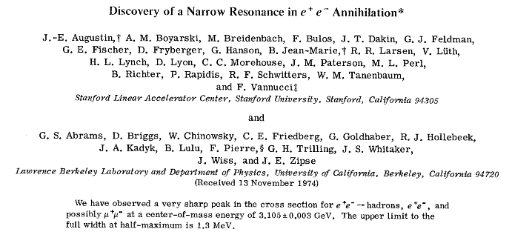

[Prof Burton Richter is a 1976 Nobel Laureate in Physics for their pioneering work in the discovery of a new kind of heavy elementary particle, J/ψ.]
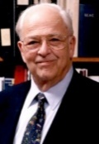

Introduction

· Give the first impression about the paper.
· Place the work into broader context.
· Relate to other relevant research.
· Say why is the work important, in plain language.
· State major achievement/limitations.
· State techniques/methods.
· Describe organization of the paper.

Example of Introduction

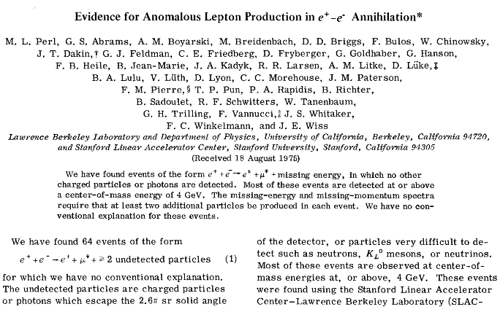

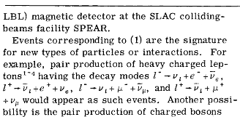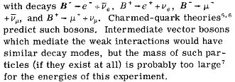

Body of the Paper

Describe your findings in an organized, structured, and logical way:

· Think about the organization ahead of actual writing.
· Create informative headings helping easy orientation.

Conclusions

· Give your article closure.
· Summary of major results.
· Prospects for future extensions.
· Possible applications, relevance to other works, fields.
Conclusions including References Example

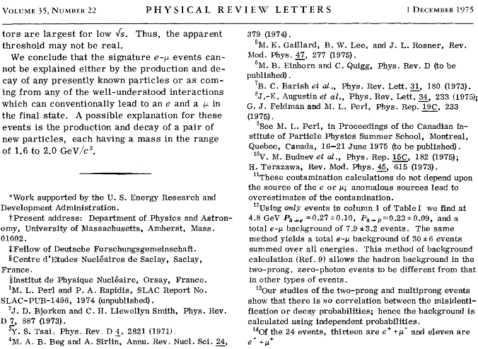

How Many Authors might a Modern Paper Have?

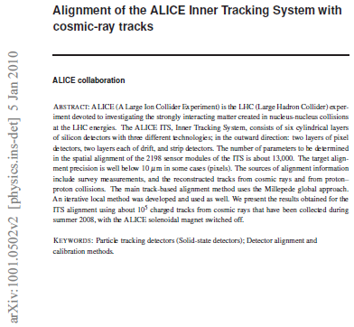

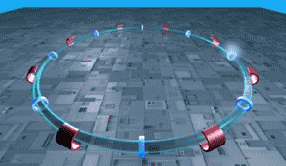 From 113 Institutes

Style of Technical papers

Guidelines explained in detail in:

American Institute of Physics (AIP) Style Manual
www.aip.org/pubservs/style/4thed/AIP_Style_4thed.pdf

Tools: LaTeX
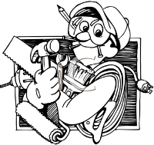 Text, Equations, Figures, Tables, References

LaTeX : http://www.latex-project.org/
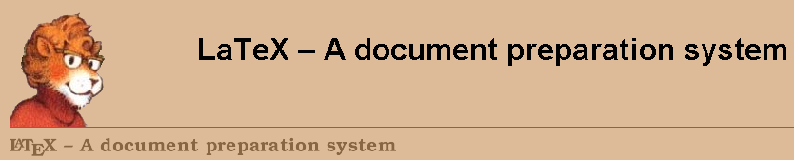

REVTeX 4

To compile Phys. Rev. Style documents: http://authors.aps.org/revtex4/

TeX archive network: http://www.ctan.org/ctan
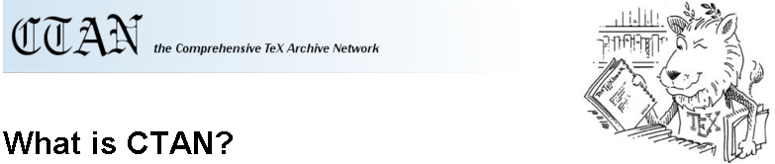

Hints for Effective Writing

Something about Style

Disclaimer

· I am not a native English speaker and I am not a writing professional. Everything that follows should be taken as my best attempt to teach my students intricacies and idiosyncrasies of physics writing, based on my own experiences and on reading inspiring literature. I claim no responsibility to the damage inflicted on students by following my advice too closely and producing unintelligible and grammar offensive research articles. Beware of my grammar hints. I am especially offensive to the articles (``the”, ``a”, ``an”, and the worst of all, none, ``…”)

· I feel absolved by being a Slavic language (read: article-free) native speaker.

Hint 1

Pick a published paper you like and try to emulate its structure and style.

Learn from eminent physics writers.

Some of my favorite physics writings are:
· S. Weinberg: Relativity and Cosmology
· R. Feynman, Leighton, & Sands: Feynman Lecture in Physics
· L. Landau & E. Lifschitz: Course in Theoretical Physics ^{(*)}

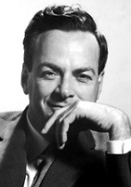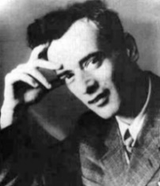
^{(*)} I would not recommend emulating the style of L&L in research papers, unless you can emulate their physics.

Hint 2

Understand what you write, be clear:
· Distance yourself from the writing to see it unbiased.
· Logic must flow.
· Ask a colleague if in doubt that writing may be incomprehensible.

Useful point: Do not write ``The energy increases with pressure”, but ``The energy increases with increasing pressure”, to be clear, since one can often mean the opposite (``At low fields the rate decreases” can mean that the rate increases with decreasing fields, but one never knows.)

Hint 3

Structuring into ideas = Structuring into paragraphs.
· Place clue sentences in the beginning.
· Read the paragraph and rewrite it if the logic does not flow.

Hint 4

Write in Active voice.
``I show that the process occurs.” Or ``These results show that …”
(NO: It is shown by these results that …)
· What you should not do is use both in the same abstract.

· Be concise, precise, and direct.
· Stay focused (not shift your point of view.)
· Do not put statements in the negative form.

Hint 5

Be consistent.

If there is an allowed ambiguity, stick to your choice throughout the paper:
· For example:
``We take five configurations for the microstate. Each microstate is defined by …”
Either pick microstate or configuration, some may get confused.

· Similarly with grammar:
For example, if you describe an experiment in the past sense, do not switch randomly to the present one.

Hint 6

No offense.

Avoid if possible words like:
· Clearly.
· Obviously.
· As is well known.
· Of course.
· Last but not least, avoid cliches like the plague; seek viable alternatives.

Hint 7

Read the guidelines:
· Early in your professional life read the guidelines for authors to the journal you write for.
Adhere to the most relevant points in future writings.

Hint 8

Do not overdo:
· Footnotes.
· In-line equations.
· References.
· Figures.
· Latin (Greek and so on) phrases.
· Acronyms.

Hint 9

Referring:
· Include only equations, figures, tables, and references that you refer to
· Carefully define every term in equations.
· Define all the lines and symbols in figures.
· Each figure and table comes with a caption.
· Number all equations (if needed.)
· All nontrivial statements should be explained or referenced.

Hint 10

Revise 5-10 times:
· Spell check.
· Grammar check (including backward reading.)
· Check for flow.
· Shorten.
· Give the paper to a colleague for opinion.
· Stop revising after a revision eliminates a previous revision, or if you are revising 10th time.
There is a little chance you will improve anything.

Final Hint

Do not put too much emphasis on writing.

It is a tool to communicate your research, no less and no more.
· An average paper is cited perhaps 4 times, and read perhaps 7
(4 plus 2 referees plus 1 random reader) times.

· You need to balance your time.
I know of terribly written articles that are cited 500 and more times.
In the end, it is the idea that you present, and not the form of the presentation, that will be
remembered.

Single Authors:

I or We.
· I prefer ``I” when addressing work done by myself:

I show that
· Using ``we” is more formal and authoritative; it diffuses responsibility
There can still be ``we”, if inviting the reader to join the discussion:
``If we substitute A for B” or ``If one substitutes A for B”.

Hints for Effective Writing

à la Barbara Goss Levi ^{(*)}

[Barbara Goss Levi is a senior editor of Physics Today, and a member of the Forum on Education's Executive Committee. This article originally appeared in the fall 1997 issue of the Forum on Physics and Society newsletter.]
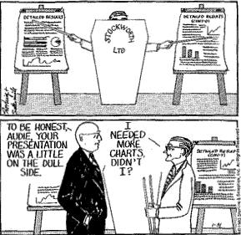

1. Practice writing short summaries of longer articles
(get the message out.)
2. Combine writing with inspiring reading
(emulate the style of your favorite writing.)
3. Get rid of superfluous words
(there is …, the fact that …)
4. Rewrite if it is not clear.
5. Define your terms.
6. Good writing is clear thinking.

None of these rules are new. They are like the simple rule to tennis players: ``Keep your eye on the ball”. The players all know the rule, but the challenge is to consistently follow it. And having completed this little piece, I wonder which of the above rules I have violated in writing it.

^{(*)} http://www.aps.org/publications/apsnews/199806/rules.cfm

Submit & Fight

Submission Letter
Dear Editor,

We submit a manuscript entitled ``Falling cats with jelly on the back: stable equilibrium versus instinct”, by E. Schroedinger and A. Einstein, for publication in Physical Review Letters. The manuscript considers the important problem of cats with a jelly spread on their back. The cats are left to fall free from a height of at least 50 cm, and observed in their fall. We have discovered that cats do not fall. Instead, they hover indefinitely. Our conclusions have far reaching consequences for both physics and biology. We are now pondering about what happens to the cats when they are entangled.

The importance of our work as well as far reaching consequences of our discovery justify our manuscript to be considered for publication in Physical Review Letters. Below we suggest physicists who should be qualified to referee our work.

Sincerely,
E. Schroedinger
A. Einstein

Suggested referees: N. Bohr (Copenhagen), L. Boltzman (Graz), L. Landau (Moscow)

Referee Reports
Re: Falling cats with jelly …
By: E. Schroedinger and A. Einstein

Dear Dr. Schroedinger:

The above manuscript has been reviewed by our referee(s). On the basis of the enclosed critique, we judge that the work does not meet the special criteria of importance and broad interest required for Physical Review Letters. We also wish to emphasize that we take strong stance on the animal rights issue and we do not endorse experimenting with live animals, with or without jelly on their back.

Yours sincerely,
E. Rutherford
Senior Editor
Encl. Referee reports

Referee A
This paper presents an experimental treatment of combined effects of mechanical rotation and animal instincts. The treatment is sound, but cruel. I question the conclusions of the manuscript on the basis that the authors used only 1 cat which must have felt depressed about being thrown repeatedly from the Physics Department windows. As is known from the work of C. Darwin, depressed cats tend to hover in the air. The authors have failed to separate the effects of depression from those of mechanical rotation and biological instincts. Therefore, I do not recommend the paper for publication in Physical Review Letters in the present form, although the subject itself is of great importance.

Referee B
The group of E. Schroedinger publishes reliable and interesting results (though I have some doubts about Dr. Einstein who tends to be off at time). The paper is well written, the results clearly stated. The subject is definitely of broad interest, as I have myself pondered about such things. The only question I have is whether the work is suitable for Physical Review Letters, or should be published in the ``American Journal of Falling Cats”? I opt for the latter

Resubmission Letter
Dear Editor,

We resubmit our manuscript entitled ``Falling cats with jelly on the back: stable equilibrium versus instinct”, by E. Schroedinger and A. Einstein, for publication in Physical Review Letters. We consider the criticism of the referees well meant, and in fact supporting publication in your journal. Referee A says ``The treatment is sound …” and ``… is of great importance”. Referee B claims that the paper is well written and of broad interest. We address the few minor critical points in the enclosed response to the referees. Since we have address ALL the referee comments, and since the comments themselves can be interpreted as positive, we strongly request that you publish our manuscript without further delay.

Sincerely,
E. Schroedinger
A. Einstein

Response to the referees
Response to referee A: We thank the referee for his or her thoughtful comments and for careful reading our manuscript. We were not aware of the important research of C. Darwin on falling cats. Taking into consideration that our cat could have indeed been depressed by both falling down so often and having jelly on the back, and so not wanting to really fall down, we have put the cat on an antidepressant (Whiskas Prozac) and let it fall several times again. We are happy to report that our original results stay unchanged. Unfortunately, the poor cat has died. Probably from an overdose of Prozac.

Response to referee B: We appreciate the referee’s well thought comments and for suggesting an alternative journal for our manuscript. We have looked at several recent issues of AJFC to see if indeed this would be the appropriate place for our cat. Unfortunately, AJFC seems to publish only very technical papers on the subject, with little emphasis on the physics involved. We strongly believe that PRL is the most suitable journal for publishing our work.

Acceptance (rejection) letter
Re: Falling cats with jelly …
By: E. Schroedinger and A. Einstein

Dear Dr. Schroedinger:

We are pleased to inform you that the above manuscript has been accepted for publication. You are requested to make a payment of $1000 toward the cost of disseminating your research results.

Yours sincerely,
E. Rutherford
Senior Editor

Reading about Physics Writing

· M. Alley, The craft of scientific writing, 3rd Edition (Springer NY, 1996)
· B. Goss Levi, Some simple rules of writing,
http://www.aps.org/publications/apsnews/199806/rules.cfm
· D. Mermin, What’s wrong with this prose? Physics Today, May 1989, p. 9
· D. Mermin, What’s wrong with this equations? Physics Today, Oct. 1989, p. 9
· D. Mermin, Writing physics,
http://www.lassp.cornell.edu/~cew2/KnightLecture.html
· A. Waldron, P. Judd, and V. Miller, Physical Review stile and notation guide, http://publish.aps.org/STYLE
· H.F. Ebel, C. Bliefert, and W.E. Russey, The art of scientific writing (VCH NY, 1987)

